The Procrastinators(Toastbusters)

1 Rishab Agarwal, 2 Shobhit Srivastava, 3 Taru Shukla

1Information Systems, Northeastern University

{ agarwal.risha, srivastava.sho, shukla.t }@northeastern.edu

***Abstract* -**  This abstract describes the project plan for a meal planning and grocery ordering app developed by the team named "The Procrastinators". The app aims to help users come up with meal ideas using the ingredients they already have, generate recipe options that incorporate those ingredients, and create a virtual shopping list to order any necessary additional items. The project plan includes using agile methodology, developing a user interface, designing and integrating backend services, and conducting testing and debugging. The team plans to use various tools such as Eclipse, Git, Github, and Scene Builder for the project's implementation.

***Keywords—Recipes, Ingredients, Meal, Speech, Video***

# **I. Problem Description**

The goal for this project is to provide a solution that will be particularly helpful for those who would like to use ingredients they already have at home, but struggle with finding recipes that fit their dietary requirements and tastes. Additionally, it can be difficult to accommodate personal preferences and dietary restrictions while also efficiently buying groceries for chosen recipes. We are also aware of the issues of food waste and environmental impact caused by unused or expired ingredients. As a result, we aim to design and implement a software application that will help users plan meals, discover recipes that utilize their available ingredients, and streamline the grocery shopping process, ultimately promoting healthy, enjoyable, and sustainable home cooking.

# **II. Analysis (Related Work)**

We have come across several approaches people use to tackle meal planning. One popular option is to use meal planning apps that provide recipe ideas, shopping lists, and nutritional information. However, most of these apps cannot customize the user's dietary preferences or incorporate their personal ingredient inventory to provide a personalized meal planning solution. Some of these apps also overlook the importance of food waste tracking and management, which is an environmental concern that needs attention.

Recent studies have looked at personalized meal planning methods that use machine learning algorithms, and the findings show that these can significantly increase user satisfaction and improve healthy eating adherence. Research by Jiang et al. (2021) developed a deep neural network-based personalized meal recommendation system that took into account user preferences, dietary restrictions, and ingredient inventory data, resulting in diverse meal options compared to traditional planning approaches.

Similarly, another study by Almeida et al. (2020) looked at data mining techniques to predict food waste and provided customized meal plans to help households minimize food waste. The study discovered that personalized meal planning can reduce food waste by up to 31%, depending on the user's food inventory and consumption patterns.

Despite these developments, some challenges exist in the existing meal planning methods. There are limitations such as the absence of access to recipe and ingredient databases, non-integration with grocery shopping and delivery services, and critical user privacy and security concerns. Therefore, for a successful and user-friendly meal planning experience that overcomes these limitations, there is a need for a comprehensive solution.

# **III. System Design**

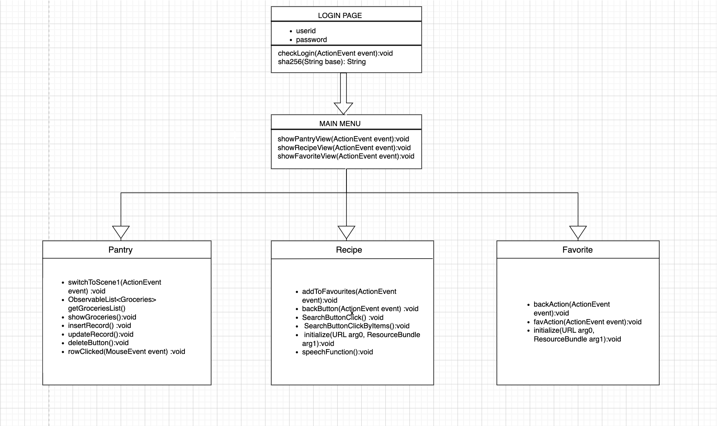

Figure 1. UML Diagram

# **IV. Implementation**

**A. User Interface Implementation**

The user interface for the app was implemented using JavaFX and Scene Builder. FXML was used to define the layout of the UI components. Custom UI components and styles were created using JavaFX and CSS. The UI allows users to input the ingredients they have and displays recipe recommendations based on those ingredients. Users can also add any additional ingredients required for a recipe to a virtual shopping list.

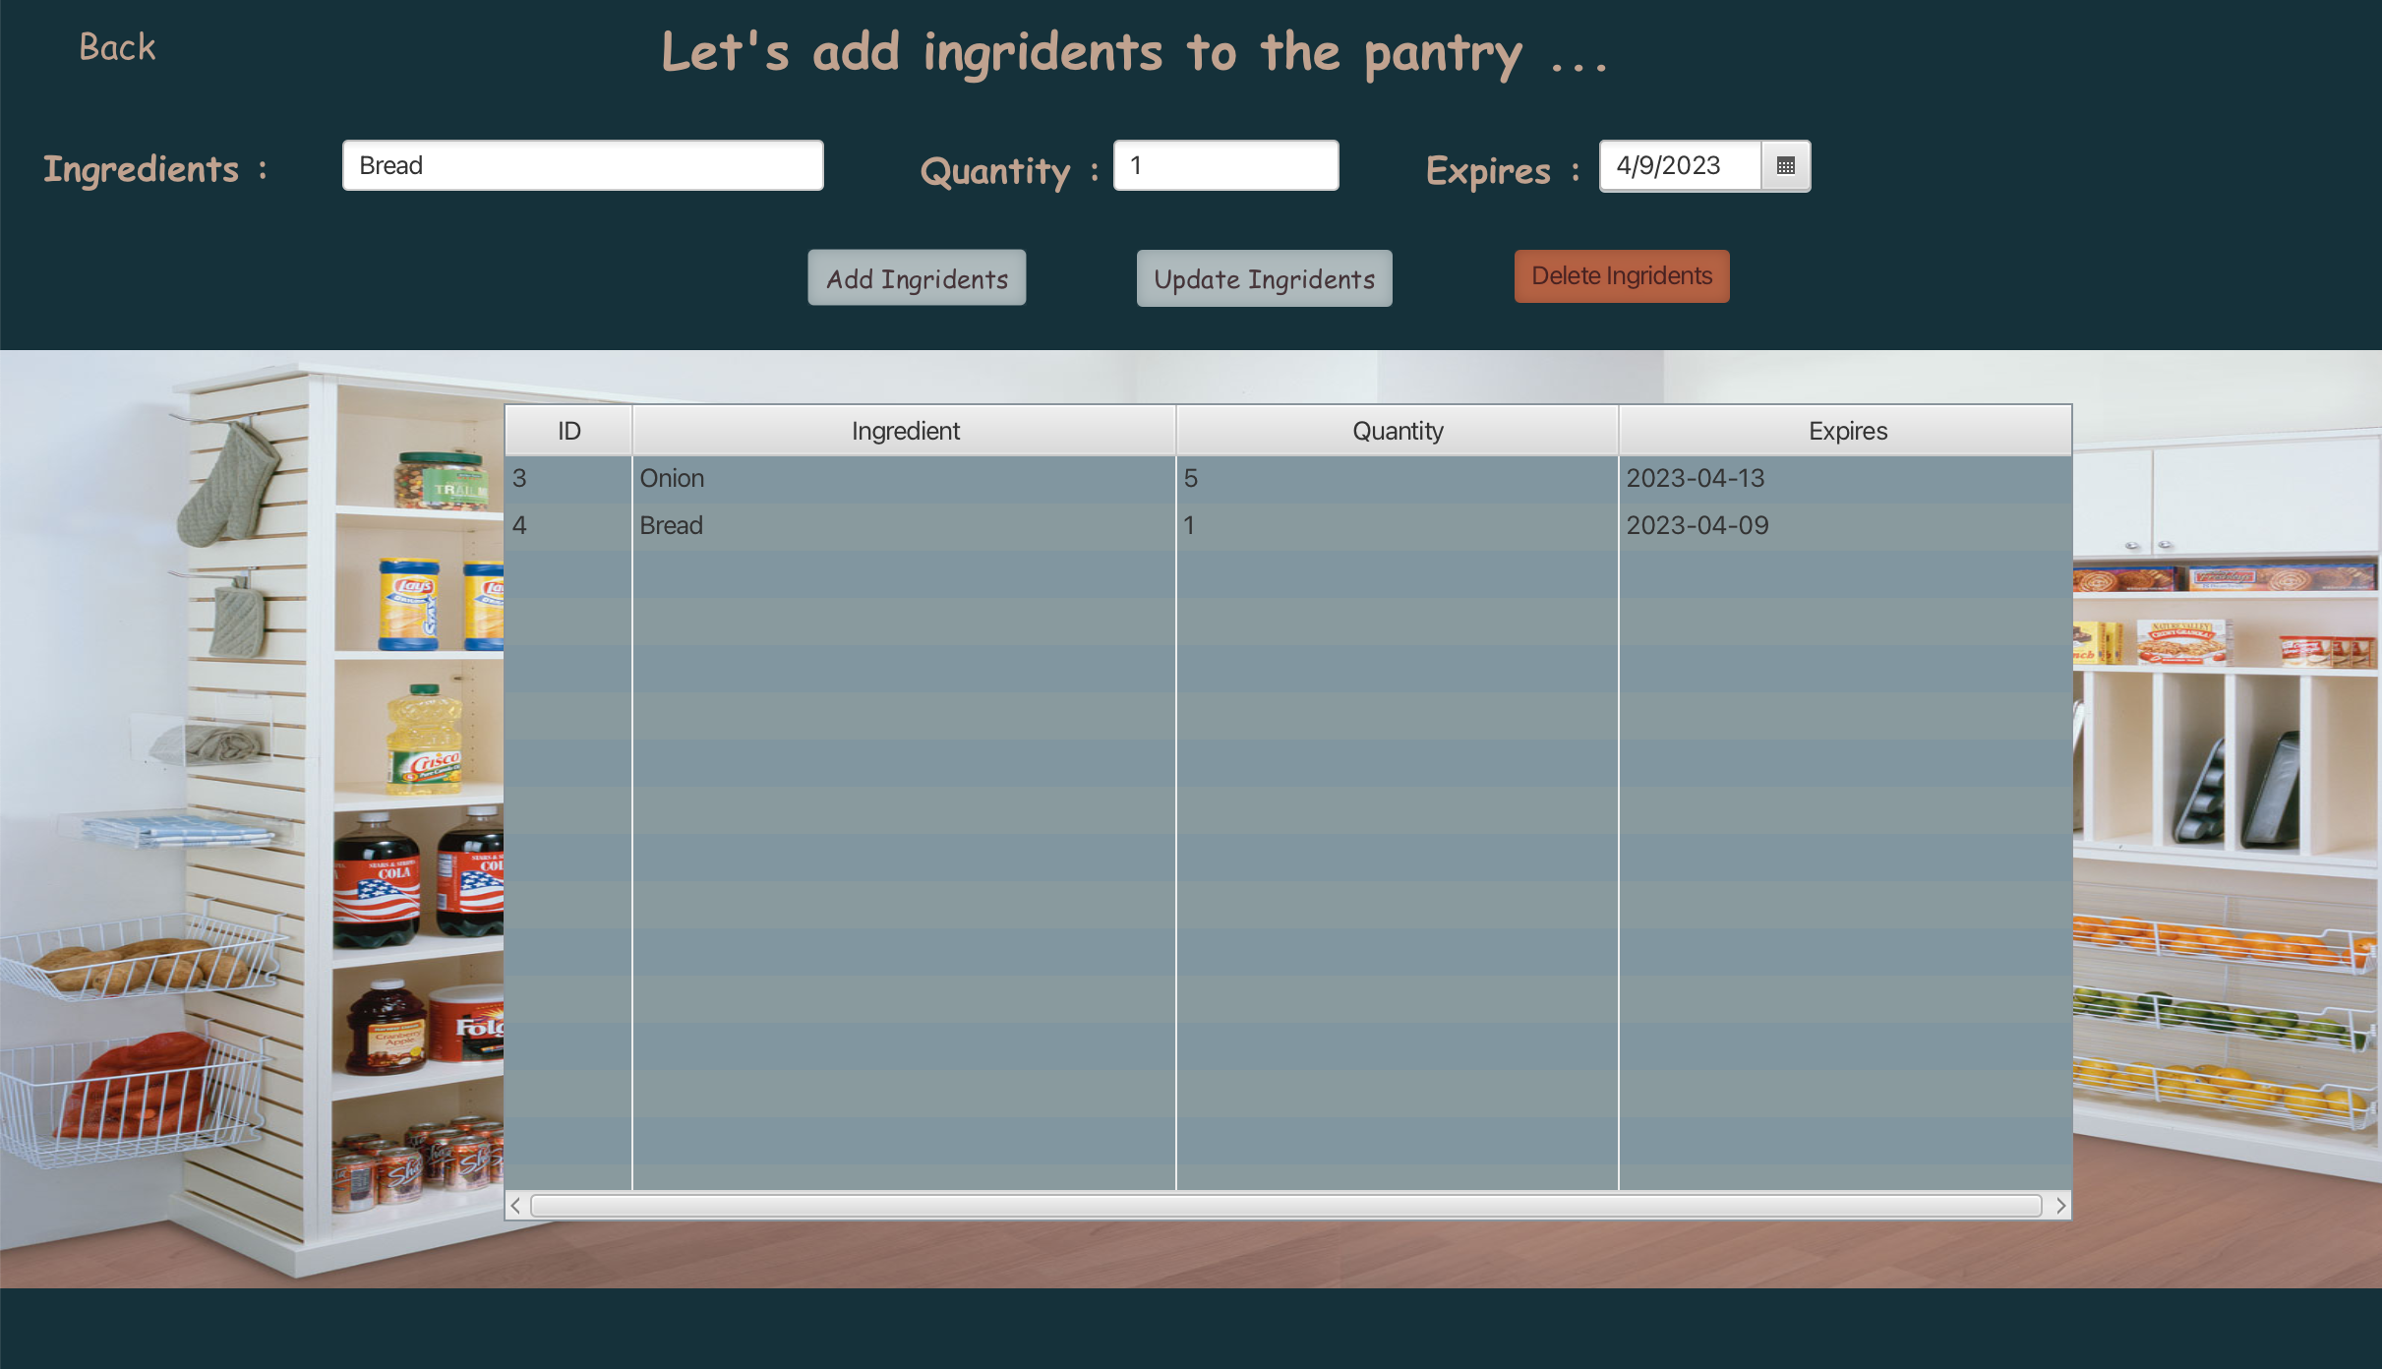

Figure 2. Pantry Screen

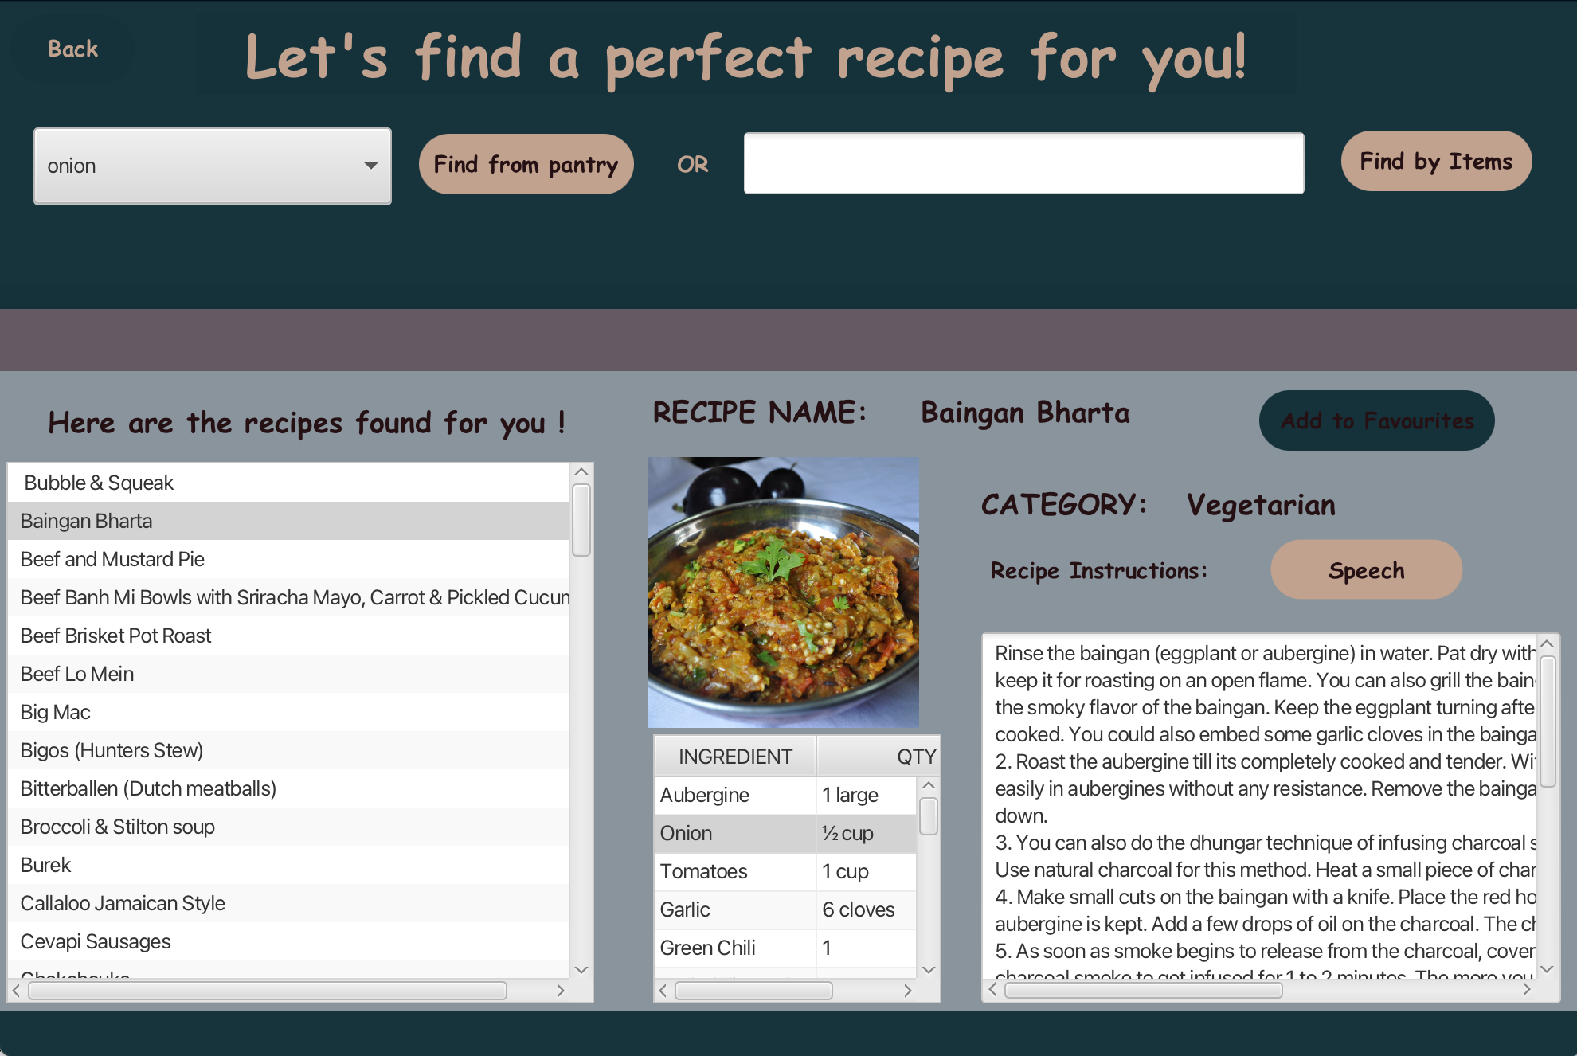

Figure 3 Recipe Screen

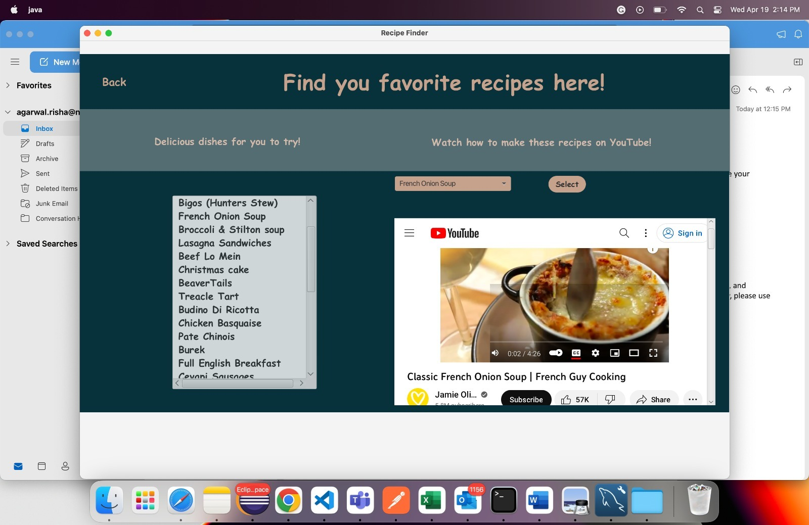

Figure 4 Favorite Screen

**B. Database Implementation**

The app uses a MySQL database to store recipe information, ingredient information, and user information. JDBC was used to implement data access and persistence. The database schema was designed to efficiently store and retrieve relevant data.

Figure 5 Sql Workbench

**C. Backend Services Implementation**

Backend services were implemented using Java. The services are responsible for retrieving recipe recommendations based on user inputs and generating a shopping list based on the selected recipes. The services are integrated with the database for data retrieval and persistence. Algorithms were implemented to optimize the recipe recommendation and shopping list generation processes.

# **V. Evaluation**

The project aims to provide a user-friendly and comprehensive meal planning that solves the problem of finding recipes that fit the user's dietary requirements and tastes while minimizing food waste and promoting sustainable home cooking. The app is designed to help users come up with meal ideas using ingredients they already have, generate recipe options that incorporate those ingredients, and in future we will have the option to create a virtual shopping list to order any necessary additional items.

The implementation of the app includes using agile methodology, developing a user interface, designing and integrating backend services, and conducting testing and debugging. Various tools such as Eclipse, Git, Github, and Scene Builder were utilized for the project's implementation. The user interface was implemented using JavaFX and Scene Builder, while a MySQL database was used to store recipe information, ingredient information, and user information. Backend services were implemented using Java, with algorithms optimized for recipe recommendation processes.

The app's implementation is expected to offer several advantages over existing meal planning apps, including personalized meal planning that considers dietary preferences and ingredient inventory data, optimization for food waste management. The app's comprehensive approach and focus on user-friendliness could result in an increased satisfaction rate, healthy eating adherence, and reduced food waste. The result of this project could benefit individuals who are interested in sustainable and healthy home cooking but face challenges in meal planning and grocery shopping.

# **VII. Discussion (Reflection)**

Our project addresses the challenges of meal planning by developing a user-friendly app that allows users to input their available ingredients and access a variety of recipes that incorporate them. It features two significant benefits. Firstly, it helps users make healthier meal choices by providing an extensive array of recipes based on the ingredients they already have at home. This feature is expected to encourage balanced diets and improve overall well-being by promoting healthy eating habits. Secondly, our app introduces users to new and mouth-watering recipes they may not have encountered before, thus enriching their culinary experience. By using the app, users are likely to explore new flavors, techniques, and ingredients, thereby enhancing their cooking skills and creativity in the kitchen, ultimately resulting in a more enjoyable meal preparation process.

As a team, we plan to implement a comprehensive approach to monitor and evaluate the app's efficiency by obtaining data on user feedback and recipe popularity. This strategy will enable us to refine and improve the app continually to cater better to the needs of our users and achieve our shared objectives.

# **VIII. Conclusions and Future Work**

In conclusion, we have successfully developed a meal planning and grocery ordering application that helps users utilize ingredients they already have and streamline the process of grocery shopping. Our solution has several advantages, including saving time and effort for users, reducing food waste, and enhancing the culinary experience. By inputting the ingredients they have, the app generates a list of delicious recipes, and users can add any missing ingredients to their virtual shopping list, which can then be sent to a grocery ordering and delivery service.

The advantages or benefits of using our solution are:

* It saves time and effort by eliminating the need for extensive research on recipes that use the ingredients users have at home.
* It helps users make healthier and more diverse meal choices by providing a range of recipes that can be made using these ingredients.
* It enhances users’ culinary experience by introducing them to new and delicious recipes they may not have tried otherwise.

The problems found but not yet explored in the project are:

* How to ensure the accuracy and quality of the recipes provided by the app.
* How to account for different dietary preferences, restrictions, and allergies of users.
* How to incorporate other factors that influence meal planning, such as budget, seasonality, availability, etc.

If our team has more time, we want to improve:

* The user interface and design of the app make it more attractive and intuitive.
* The functionality and features of the app to make it more personalized and interactive.
* The scalability and sustainability of the app to make it more accessible and adaptable.

# **IX. Job Assignment**

**Rishabh Agarwal:** Design and Developed Recipe Screen, Text to Speech integration, Meal Api Integration, Sql Integrations for Recipe Screen.

**Taru Shukla:** Design and Developed Pantry, Menu & Favorite Screen. Also implemented CRUD operations, Sql Integrations for Pantry and Favorite Screen.

**Shobhit Srivastava:** Design and Developed Login Screen, SHA 256 based password hashing, Integrated you tube video for recipes, Sql Integrations for Login Screen.

##### **References**

1. <https://www.themealdb.com/api.php>
2. <https://openjfx.io/openjfx-docs/>
3. <https://dev.mysql.com/do>
4. <https://docs.oracle.com/javafx/scenebuilder/1/use_java_ides/sb-with-eclipse.htm>
5. <https://www.javatpoint.com/java-collection-iterator-method>
6. <https://www.geeksforgeeks.org/converting-text-speech-java/>